Classified Non- IT Supervisor Guide to EvalS
Revised August 2014 / Copyright 2014 |  | EvalS Performance Evaluation System

Supervisor User Guide to EvalS –
Log onto the EvalS System
Go to: https://myosu.oregonstate.edu/web/myosu/employee
Use ONID User Name and Password to log on
You will arrive at the MYOSU Welcome Page. Click on either “Employee” or “Supervisor”
Logging on to the EvalS System
You will receive an email when you need to complete a task in EvalS. Click on the appropriate link within the email and it will bring you to your My OSU log on. Use your ONID user name and password to log on. You will now see your My OSU home page. The EvalS section will be on the right side of the page.
OR
At your My OSU home page, the EvalS information will appear on the right hand side of the page
Look for the tab in the EvalS section titled ROLES. Click on ROLES, and select SUPERVISOR
Note: You can access the evaluation information for any of your employees by looking at the EvalS section titled My Team, and clicking on their name.

Note: If you need to return to the EvalS beginning section at any time, look for the tab titled, “Home” and click on it.
Helpful Hint: Having the information you wish to enter into EvalS available on a separate piece of paper will allow the process to be quicker and smoother.
GOALS
Purpose: To assist supervisors of classified employees to enter goals into the EvalS system.
Overview –
Well crafted goals provide a clear understanding of what is expected and at what level they will be held accountable. They build a partnership between employees and their supervisors and managers in documenting opportunities for meeting evolving business needs, as well as personal and/or career development.
The goals section of EvalS documents performance and development goals for the evaluation period.
At least one goal must be entered into the Goals section of EvalS. For each goal you must select at least one of the evaluation criteria (communication, technical, team building, and dependability/reliability
When to Review Goals –
Employees enter goals into EvalS and submit them to the supervisor for review. The supervisor will review, work through any modifications and should have the goals approved for the new evaluation period no later than 30 days after the start of the new evaluation period. You will be prompted to review the goals section once your employee has submitted their goals.
Note: This is the ideal time to review and update the employee’s Position Description if necessary. You may review the Position Description by clicking on the View PD tab at the top of the evaluation form.
How to enter Goals–
Log onto the EvalS system and click on Roles and select Supervisor
The Notifications Section will have messages about upcoming deadlines in the My Administrative Actions area. (I.e. Bennie Beaver goals are due would appear starting 30 days prior to end of the evaluation period).
If it indicates that goals need approval, CLICK on that message (ex. Benny Beaver goals due) and EvalS will take you to the appropriate section for reviewing the goals for that employee.
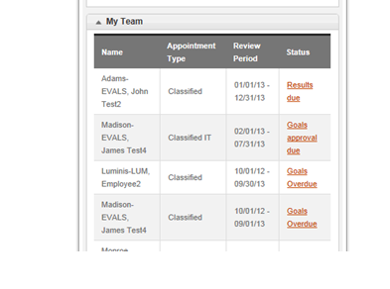

Reviewing the Goals Submitted by the Employee
Once your employee has finalized and entered the goals they would like included they will select SUBMIT GOALS. As the supervisor, you will receive an email, and/or you will see that you need to review and approve goals in the Notifications/ My Administrative Actions section.
Email
Subject: Action Required: Employee Performance Evaluation Goals Submitted for Review/Approval
The goals for <employee name>, <position title>, for the <Review Period> have been submitted and are ready for your review. Before approving these goals, please have a discussion with your employee to ensure these goals are achievable and realistic, and appropriate to the employee’s position duties. You may notify the employee via the EvalS system if modification to the goals is required.
Use the following link to access the EvalS System
https://myosu.oregonstate.edu/web/myosu/employee

As the supervisor, you do have the ability to modify the goals directly in EvalS. Or, you may select the option Goals Require Modification. There is a text box available for you to provide feedback labeled Supervisor Goal Comments. Selecting the option Goals Require Modification will trigger an email to the employee indicating that they need to have further discussions with you and make the appropriate changes. The employee will then re-submit the goals in EvalS.
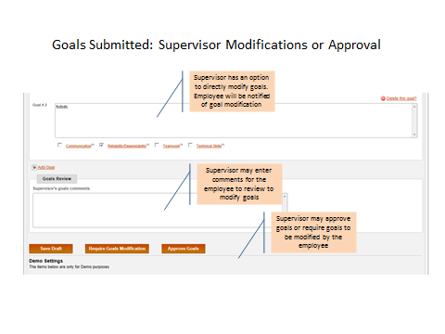
Once the goals entered by the employee and the supervisor have been finalized, the Supervisor will select Approve Goals.
WARNING: MAKE SURE BOTH YOU AND THE EMPLOYEE HAVE FULLY COMPLETED ALL EDITS TO THE GOALS BEFORE SELECTING APPROVE GOALS
Please be mindful of the possible options concerning Goals in EvalS:
Save Draft – Will keep the goals available for editing
Goals Require Modification – This will signal to the employee the need to have further conversation regarding the goals and to make the appropriate changes.
Approve Goals – Signals that the process of goal setting is final and complete.
WARNING: Once the goals are Approved in EvalS they should only be changed if the job substantially changes, or the employee accepts another job.
RESULTS
Purpose: To assist supervisors of classified employees to enter results into the EvalS system.
Overview –
The Supervisor Results sections of EvalS documents the employee’s progress in meeting their goals.
The employee and the supervisor EACH have a SEPARATE section for entering results for each of the goals.
When to enter Results –
Results may be entered any time after the GOALS have been approved. They are due to be entered into the EvalS system 30 days before the end of the current performance evaluation period.
How to enter Results –
An email will alert you 60 days prior to the results being due.
E Mail
Subject: Action Required: Performance Evaluation Results and Appraisal Due
It is time to enter the Performance Evaluation Results and complete an Appraisal for <Employee Name> for the <review period> review period. You will enter results describing how your employee met goals in the areas of Communication, Teamwork, Technical Skills, and Dependability/Reliability. You will also complete the Supervisor Appraisal section. Please complete this task within <30> days.
Use the following link to access the EvalS System:
https://myosu.oregonstate.edu/web/myosu/employee

You may click on the link provided to bring you to the My OSU log in. Use your ONID user name and password to log in. When you see the My OSU Home Page the EvalS section will be on the right side of the page. Be sure to click on the ROLES tab and select your role as Supervisor.
In the Notifications /My Administrative Actions area, you will see a message indicating that the results for your employee are coming due (i.e. Benny Beaver results are due will appear 60 days prior to end of the evaluation period).
Click on the Supervisor Results Due message and it will bring you to the Results section for that particular employee
Note: If you are entering results for the employee throughout the year, log on to the My OSU page, select your role as supervisor, and look for the My Team Section in the EvalS area. Click on the employee name and it will take you to their evaluation.
ALERT – Outside of 60 days prior to the results being due, you may only select SAVE DRAFT after entering results information in the Supervisor Results sections. The supervisor will not be able to view employee results until the employee submits them in EvalS.
Enter the results related to the goals for each Performance Criteria that were set for this employee. Your input to their results will be entered in the text box labeled SUPERVISOR results. You will notice that your employee has a separate text box to enter the results they have noted regarding their performance. You may enter results in the SUPERVISOR results sections, but not in the EMPLOYEE results sections. Unlike goals, you cannot edit the Employee Results sections.
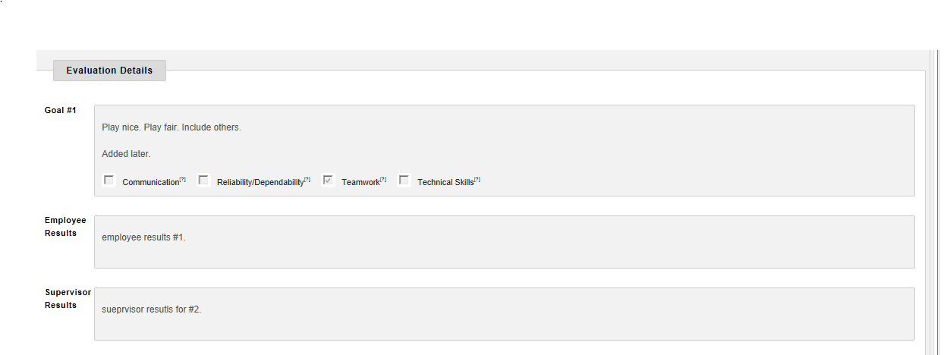

Note: Be sure to emphasize the results relative to the stated goal. You may also want to describe the approach the employee took in completing the goal, or how it was accomplished. When you have completed entering the results, go to the bottom of the page and select Save Draft
If you need to edit the results - Go through the same access steps and you may edit your results by selecting the name of the employee in the My Team Section. Then go to the bottom of the Results page and select Save Draft again.
Once the results are complete from both you and your employee, go to the bottom of the page and select Save Draft.
Before you can take the next step (Submitting the Appraisal for Review) you must also complete the Appraisal Section and determine the Performance Rating for the employee.
COMPLETING THE APPRAISALS AND DETERMINING A PERFORMANCE RATING
Once you have completed inputting the results, you will need to write an overall appraisal summary that reflects the employee’s performance over the entire evaluation period. You will find a text box labeled Supervisor Appraisal where you will enter your comments.
Note: Be sure to include relevant information, including mitigating circumstances where goals were not completed. It is helpful to include not only the result (goal completion), but to add comments concerning how the goal was completed. That is, their approach and the effects of that approach. In addition, if you determine that there are areas of deficient performance, make sure that they are noted in the Appraisal Summary.
In addition to the appraisal summary, you are required to select the overall Performance Rating for this employee. You have four choices:
- Makes outstanding contribution in critical areas while meeting all major requirements of the position.
- Performs requirements of the position in a satisfactory manner
- Fails to meet performance requirements of the position in major or critical areas
- No Rating
NOTE: The “No Rating” option in EvalS is reserved for particularly unusual situations and supervisors should consult with Human Resources prior to making this selection. Primarily, the “No Rating” selection is utilized when there has been a significant disruption in the evaluation cycle. There may be a change in reporting structure, a substantial change in job responsibilities, or the performance evaluation process may have broken down and needs to be re-established.
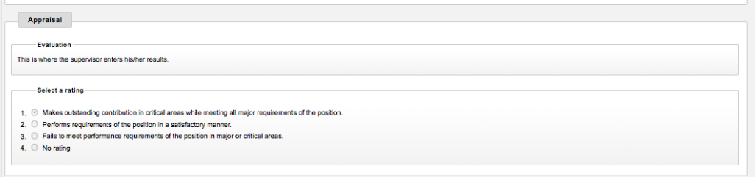
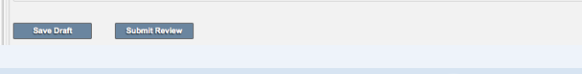
Once the results and appraisal sections are finalized and the Performance Rating is selected, you may then select Submit Appraisal for Review.
Business Center Human Resources Review
When the Appraisal is submitted for review in EvalS, an email will be sent to the designated HR Reviewer within the Business Center HR department.
The HR staff member will review the Performance Evaluation. There is a section where their comments can be entered – HR Comments
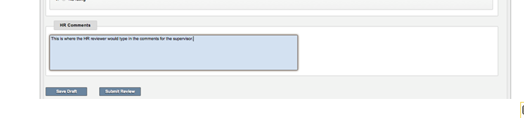
If the HR reviewer has concerns, questions, or suggested modifications, it is highly likely they will contact you for some additional conversation.
Note: Only the supervisor and HR have the ability to view the HR Comments. At no time will they be available for the employee to review
The Business Center HR reviewer will then submit the review in EvalS
That will trigger an email to the supervisor, and a message in the EvalS Notifications – Administrative Actions section that the Performance Evaluation is ready for Release to the employee.
You will receive the following email once the HR Review is complete
E Mail
Subject: Action Required: Performance Evaluation Release Due
The performance evaluation for <Employee Name>, <Position Title>, for the <Review Period> review period has been reviewed by the Business Center HR representative and is now ready to be released to the employee. Please discuss the results and appraisal with your employee prior to releasing the evaluation in EvalS
Use the following link to access the EvalS System
https://myosu.oregonstate.edu/web/myosu/employee

EVALUATION CONFERENCE, RELEASE and SIGNATURES
When the performance evaluation has been reviewed and ready for release, that is the opportunity for the supervisor to make any modifications they discussed with the HR Reviewer.
As the supervisor you will schedule a time with your employee to discuss the results, your overall appraisal of the employee, and their performance rating for the evaluation period.
When that conversation and meeting is complete, it is the opportunity to make any final modifications.
Only after the meeting with the employee will you go into EvalS and “release” the evaluation to the employee.
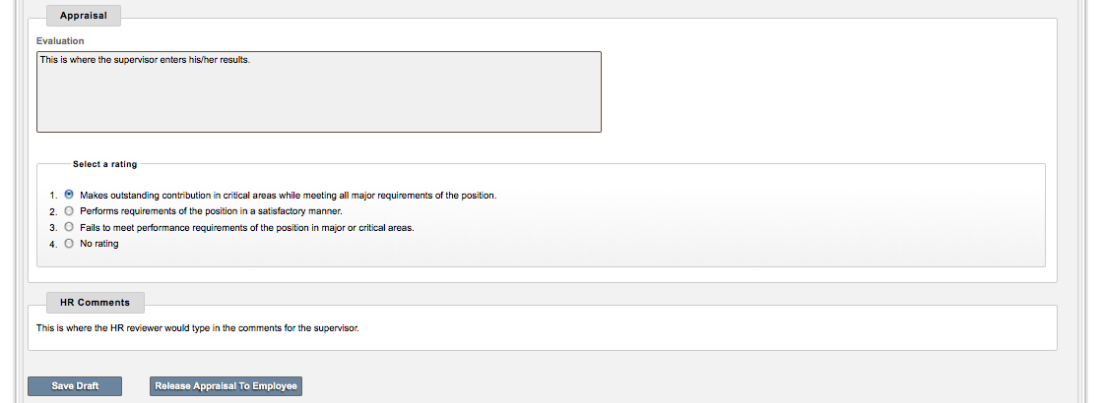

The employee will receive an email indicating that their evaluation has been “released” and their signature is due. They will be able to view the entire contents of the evaluation, with the exception of any comments from the HR Reviewer.
Employees have no ability in EvalS to alter or edit the supervisor’s entry into results, the appraisal summary, or the rating of their performance.
Signatures and Rebuttals
Once the employee has received the email and had the opportunity to review the completed performance evaluation in EvalS, they will electronically “sign” it, and have the opportunity to submit a rebuttal if they choose to.
Signing
The employee will click on the box next to the statement I acknowledge I have read this Performance Evaluation.
An employee’s “signature” reflects that the employee has seen and had an opportunity to review the evaluation. The employee’s signature does not mean s/he agrees with what is written.
What if the employee refuses to electronically sign the Performance Evaluation?
If an employee refuses to sign the evaluation after 60 days from release, the supervisor should print a copy of the evaluation and note on the evaluation that the employee declined to sign and indicate when they met with the employee to review the contents. The supervisor, and another manager, should sign the document and send the copy to Human Resources at the Business Center so that it can be entered into the employee’s personnel file. Also, contact the EvalS administrator or Business Center to close the evaluation.
Rebuttals in EvalS
At the same time the employee electronically “signs” the evaluation in EvalS; they have the opportunity to submit a written rebuttal in the EvalS system. If they choose to do so, and want the rebuttal to be in the EvalS system, they must enter the rebuttal at the same time they electronically sign the evaluation. They cannot return to EvalS later and submit a rebuttal in the system.
NOTE: If a rebuttal is not entered at the point of employee signature, a written rebuttal may be subsequently submitted separately within 60 days to the Business Center Human Resources Department. It will then become a part of the employee’s personnel file.
If a rebuttal is submitted into EvalS, the supervisor will be notified with an email message and a notice in the Notifications section of EvalS. By clicking on that message, the supervisor can read the rebuttal and will select the option I have read this rebuttal.
E Mail
Subject: Action Required: Employee Rebuttal Submitted to Performance Evaluation
Your employee, <Employee Name>, has submitted a rebuttal to the <Position Title>, <review period> review period performance evaluation. Please review the rebuttal, and contact your Business Center HR Representative if further action is required.
Use the following link to access the EvalS System:
https://myosu.oregonstate.edu/web/myosu/employee
An email message will also be sent to a Business Center HR contact notifying them that a rebuttal has been submitted.
The signature and any rebuttal bring to a close the evaluation cycle. Once one evaluation period is complete, formulating new Goals will quickly be required for the new evaluation period.
You will receive the following E Mail confirming that the Performance Evaluation is complete
E Mail – To employee with cc to manager
Subject: Notification – Performance Evaluation is Complete
Your performance evaluation for the <review period> review period is now complete. If you have not already received a copy of your completed performance evaluation, you may print one from the EvalS system.
Use the following link to access the EvalS System:
https://myosu.oregonstate.edu/web/myosu/employee

CLOSING A PERFORMANCE EVALUATION DUE TO AN UNEXPECTED CHANGE
Under the following circumstances a supervisor should request an evaluation be CLOSED.
- Job Termination of the employee being evaluated (Promotion, Transfer, Layoff, Retirement, Trial Service Removal, Dismissal, or Promotional Trial Service Removal)
- Position on Leave (Long-term leave, not summer job on leave)
- Refused to sign the performance evaluation
In order to close an evaluation, contact an EvalS Administrator.

