Online Recruiting System – PeopleAdmin 7
Student Employment Initiator Guide – Creating Student Postings

General Login Process

► Click link: https://jobs.oregonstate.edu/hr
► Select the “Online Recruiting System Login – Click Here” link and enter your ONID credentials
► Default page upon log in is the Home page. If you are denied access, please email employment@oregonstate.edu for assistance.

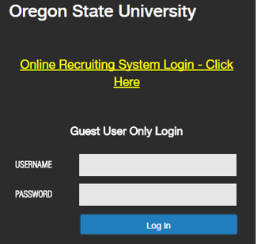

Ensure you are in the Student Employment Initiator role. If your role is not Student Employment Initiator, select the correct role from the drop down in the upper right corner of the screen.

Creating a Posting

Before you begin: Familiarize yourself with the Student Job Categories and Rates if you are unclear on what category you need to recruit for: http://hr.oregonstate.edu//files/ercc/comp-plan/studentpayrates.pdf

To begin a New Posting:
- From the Main Menu, choose Posting, select Student – and select
- Next, select the type of student posting you wish to create. (See descriptions below). 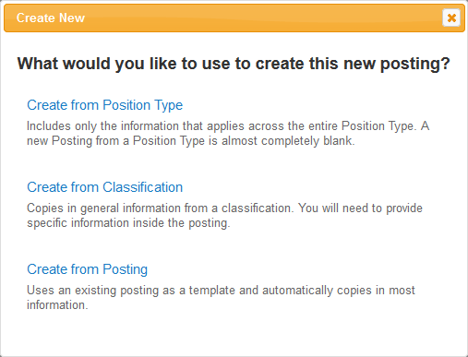
You may create a Job Posting from one of these options ONLY:
Create from Classification (Option 1): Copies in base classification information. Use this option when creating a unique STUDENT posting.
Create from Posting (Option 2): Allows you to clone (copy) an existing posting and make edits as needed. Use this option when creating a STUDENT posting for which you have already created a similar posting and need to make only minor edits. Good option when you recruit for similar positions frequently.

Create from Classification – Option 1
- The system will default a list of approved Student Classifications.
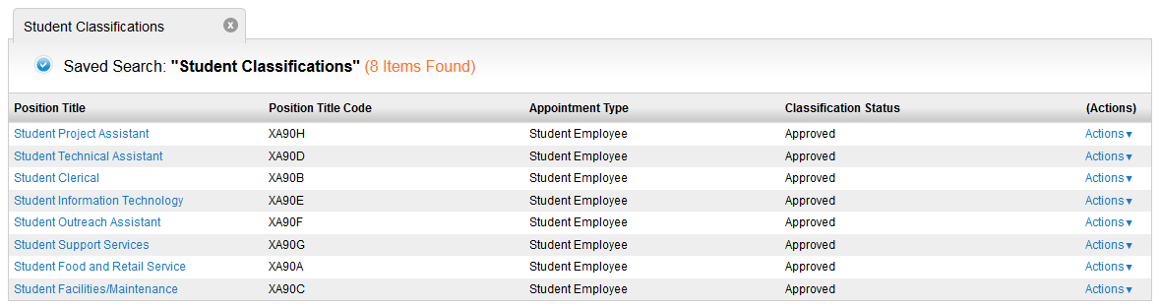

- To view the classification, open it by clicking on the Position Title or by clicking on the Actions link at the right of the Position and selecting View.

- To Create Posting from the Position Title, choose “Create From” from the Actions link or,
“Create Posting from this Classification” after selecting View from the Actions link.
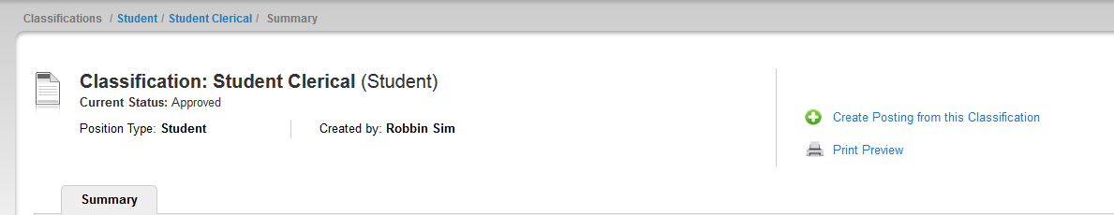

- A New Posting page will appear for general settings information. Enter an “x” in the Job Title field as you copy the Position Title to this field on the next page. Complete each field as appropriate except for the “References” section as it does not apply to Student positions. Ensure the “Accept online applications?” checkbox is checked.

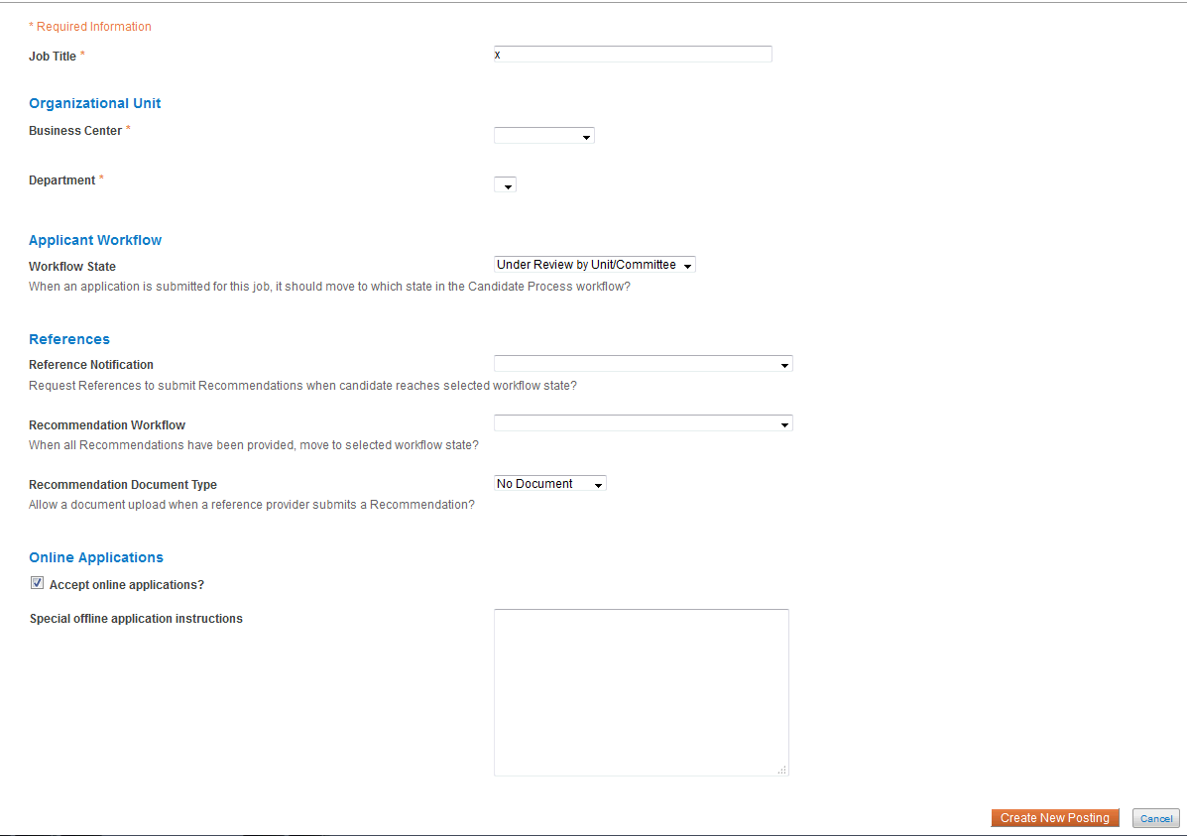

- When done, click on to continue the posting and move to the next section in this manual or select “Cancel” to return to the home page.

Create from Posting – Option 2

- Search for previous posting, using information given on the Student Position Request Form.
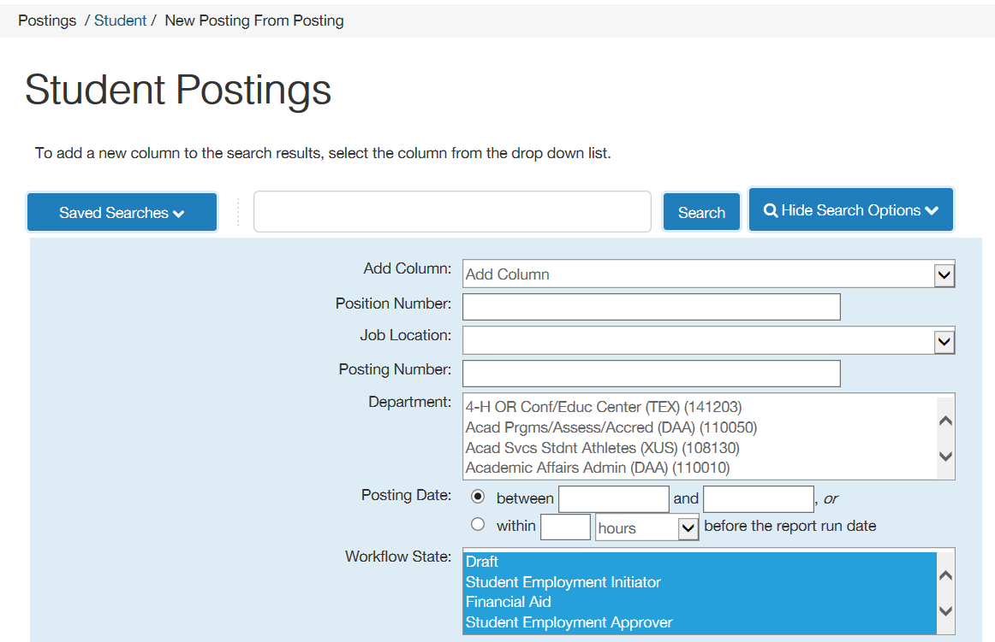

- Select the posting you wish to clone (copy). You can then view the posting to ensure this is the correct posting to clone.
- Select “Create Posting from this Posting”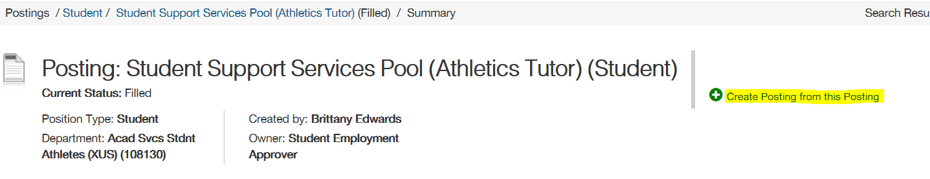

- A New Posting page will appear for general settings information. The text fields will be pre-populated with the information from the cloned posting. Ensure the “Accept online applications?” checkbox is checked.
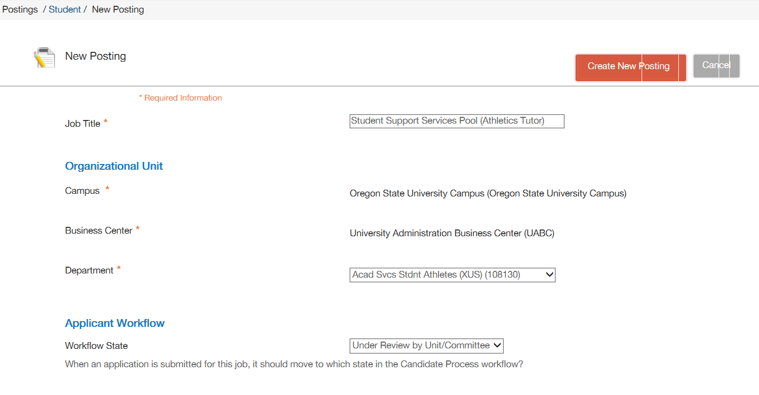
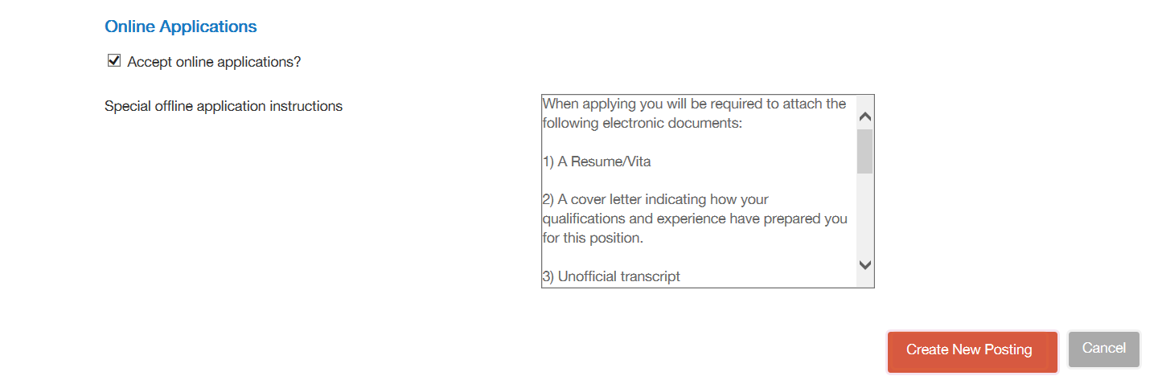

- When done, click on to continue the posting and move to the next section in this manual or select “Cancel” to return to the home page.

Create/Update/Complete Posting Details

- The menu at the top left directs the information you will supply to complete the Posting. You may navigate to each section by selecting the category of information or clicking on the Next button:
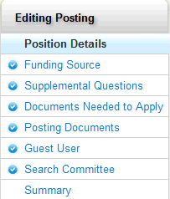
Position Details* – You will need to complete all applicable fields in the position details section, including the General Position Information, Position Summary, Position Duties, Qualifications, etc.

Funding Source – Information copies in from the Position Description.
Supplemental Questions – Add questions that refine the list of qualified applicants. Questions will be reviewed and approved by your BC HR team.
Documents Needed to Apply – Choose required or optional documents for applicants to attach during the application process.
Posting Documents – Upload required or relevant search related documentation i.e. draft advertisement (optional), waiver of search justification, etc.
Summary – Posting details summarized on one screen

POSTING DETAILS PAGE
Position Title: Auto-Populates to appropriate student position title based on classification selected
Job Title:
Copy the Position Title field into this field. This job title field appears allows applicants to utilize key words to search for positions.

You may add a brief description after the job title i.e.: Student Clerical (Receptionist)
Appointment Type: Auto-Populates as Student Employee based on classification selected
Position Number: Add the appropriate pooled position number assigned to your department/hiring unit.
Job Location: Select the appropriate job location from the drop down menu.
Employee Class: Select XA from the drop down menu.
FLSA Status: Select Non-Exempt/Eligible for Overtime from the drop down menu.
Position Appointment Percent:
Make sure this is listed as a percent, not FTE (50 vs. 0.50). All undergraduate student employee positions should be no more than .50 (part-time, 20 hours a week). All graduate student employee positions should be no more than .49 (part-time, 19.6 hours a week).
Appointment Basis: Select 12 from the drop down menu.
Min Hourly Rate: Auto-Populates based on classification selected
Max Hourly Rate: Auto-Populates based on classification selected
Position Summary: This is a brief description of why the position exists and what the primary function of the position is.

Add the standard language (examples below) at the very beginning of this section.

Example: This recruitment will be used to fill one part-time (a maximum of 20 hours per week) Student Clerical position for the Department of Chemistry at Oregon State University (OSU).

If the position job location is anywhere other than Corvallis, add the job location of the appointment after the opening statement. Example: This position will be located in Roseburg, OR

Position Duties:
A general description of duties will auto-populate from the student template used to create the posting. Update the duties so that they are specific to the position.
Please include any security-sensitive duty statements that apply (i.e.: working one-on-one with minors, access to confidential data, etc.…)

Please make sure that if a CHC or MV check is required, that the duties/access supports the requirement. See the links in the Critical, Security-Sensitive Position and Motor Vehicle History Check fields above for guidance.
Minimum Qualifications: Auto-populates with the following from the student classification: Employment Eligibility Requirements (http://fa.oregonstate.edu/stu-manual/500-employment-eligibility-requirements)

Required Qualifications:
Add required qualifications as appropriate for the position.

If the position requires a criminal history check, add (if a pool position change to “may require”):
This position is designated as a critical or security-sensitive position; therefore, the incumbent must successfully complete a Criminal History Check and be determined to be position qualified as per OSU Standard 576-055-0000 et seq. Incumbents are required to self-report convictions and those in Youth Programs may have additional Criminal History Checks every 2 years.

If the position requires driving as an essential function, add (if a pool position change to “may require”):
This position requires driving a university vehicle or a personal vehicle on behalf of the university; therefore, the incumbent must successfully complete a motor vehicle history check, possess and maintain a current, valid driver's license in their state of residence, be determined to be position qualified and self-report convictions as per University Policy 05-030.
Preferred (Special) Qualifications:
Add preferred qualifications as appropriate for the position.

Working Conditions/Work Schedule:
Add a general description of working conditions/work schedule.

Criminal History Check - Critical, Security-Sensitive Position:
If the radio button indicates yes, it means the finalist has security-sensitive duties (see CHC Crosswalk: http://hr.oregonstate.edu/sites/hr.oregonstate.edu/files/ercc/criminal-history/background-check-crosswalk.pdf ) and must successfully pass a criminal history check prior to being placed into service.

For more information on criminal history check requirements, see: http://hr.oregonstate.edu/manual/criminal-background-check

You should make sure the criminal history check language appears in the minimum/required qualifications section if one is required.

POSTING DETAIL INFORMATION
Posting Number: Assigned and will auto-populate when forwarded to the Student Employment Approver.
Number of Vacancies: Enter the number of positions being recruited for – if a pool you may enter a range.
Anticipated Appointment Begin Date: enter date as appropriate
Anticipated Appointment End Date: enter date as appropriate
Posting Date: Select a desired posting date.
For Full Consideration Date: (OPTIONAL)
Use this field if you wish to consider applications at a date prior to the standard closing date. Applications received after this date may or may not be considered.
Closing Date: Select a desired closing date. The Minimum Posting Period is 1 days for all student employee positions.
Indicate how you intend to recruit for this search:
Select as appropriate:
“Competitive/ Student – open to ALL qualified/eligible students” OR
“Competitive / Work Study – open to qualified/eligible work study students only” OR
“Non-Competitive – Job will last 7 days or less, or a unique qualification is required”

If a position is open to both work study and non-work study students, select:
“Competitive/ Student – open to ALL qualified/eligible students”***

If you have an appointee(s) identified and the position is 7 calendar days or less OR the appointee is uniquely qualified, select: “Non-Competitive – Job will last 7 days or less, or a unique qualification is required”

Special Instructions to Applicants:

If this position is intended for work study only, copy and paste the following statement at the top of this section:

<b>This position is open to qualified/eligible work study students only</b>

Copy and paste the following information – edit as appropriate as this will vary depending on documents to be submitted:

When applying you will be required to attach the following electronic documents:

1) A Resume/Vita

2) A cover letter indicating how your qualifications and experience have prepared you for this position.

For additional information please contact: insert contact information

For ALL positions insert both of the following statements:
OSU commits to inclusive excellence by advancing equity and diversity in all that we do. We are an Affirmative Action/Equal Opportunity employer, and particularly encourage applications from members of historically underrepresented racial/ethnic groups, women, individuals with disabilities, veterans, LGBTQ community members, and others who demonstrate the ability to help us achieve our vision of a diverse and inclusive community.

Note: All job offers are contingent upon Human Resources final approval.

Copy and paste the following language into the Special Instructions section if applicable:

If a Criminal History Check is required, add the following language (for pools state “may”):
This position is designated as a critical or security-sensitive position; therefore, the incumbent must successfully complete a Criminal History Check and be determined to be position qualified as per OSU Standard 576-055-0000 et seq. Incumbents are required to self-report convictions and those in Youth Programs may have additional Criminal History Checks every 24 months. Offers of employment are contingent upon meeting all minimum qualifications including the Criminal History Check Requirement.

If a Motor Vehicle History Check is required, add the following language (for pools state “may”):
This position requires driving a university vehicle or a personal vehicle on behalf of the university; therefore, the incumbent must successfully complete a motor vehicle history check, possess and maintain a current, valid driver's license in their state of residence, be determined to be position qualified and self-report convictions as per University Policy 05-030. Offers of employment are contingent upon meeting all minimum qualifications including the motor vehicle check requirement.
Pass/Fail Messages:
When applicants successfully apply to postings, they receive a “Confirmation” page in the system that presents a confirmation number for reference. On the “Confirmation” page is also the text inside the “Pass Message” data field that thanks them for their interest in the position, etc.

The “Fail Message” will pop up on the screen if an applicant answers a posting-specific question with an answer that disqualifies him/her. The message thanks them for their interest, and specifically states that based on their response, they do not meet the minimum/required qualifications for the position.

These pass/fail messages should not be modified without first consulting with employment@oregonstate.edu. Only under exceptionally rare circumstances would a modification of this text be justified.

Quick Link for Internal Postings: Auto-populates
Non-Competitive Searches Sections: Complete all fields in this section
Recommended appointee: The name of the recommended appointee should be listed here
University ID: Should be included if the appointee has ever had a job record at OSU
Reason: 7 Consecutive Calendar Days or Less or Uniquely Qualified
Justification: If uniquely qualified is selected, please provide a justification indicating how the appointee is uniquely qualified
FUNDING SOURCE
Funding Source: Select appropriate funding source from drop down menu.
Labor Distribution (Index, Account Code, Activity Code, Labor %): Enter appropriate labor distribution information for payroll.
Position Budget Type: Ignore this field
SUPPLEMENTAL QUESTIONS (As Applicable)
This section is where you will create the Supplemental Questions (SQs) that applicants will respond to when applying to the posting. These questions can refine the list of qualified applicants and be exported to sort, filter and create reports. Step by step instructions are included within the system. Questions will be reviewed and approved by your BC HR team.

DOCUMENTS NEEDED TO APPLY (As Applicable)
Choose required or optional documents for applicants to attach during the application process.

POSTING DOCUMENTS (As Applicable)
Upload relevant search related documentation as appropriate.
SUMMARY - displays details about the Posting
HISTORY
History – displays all transactions associated with the Posting, when it was created, any actions, notes or distributed emails time in status, who prepared the action, time and date stamp. As the number of transactions grows, History may be filtered by clicking on the boxes for Workflow, Notes and Emails. The “Add a new note” option is where you would add any comments you would like noted in the history of the posting or as communication to the Student Employment Approver. Your name, role, date and time are automatically added to each note.

Please also note any specific information/instructions you may want the Student Employment Approver to be aware of as well. There is a 1200 character limit per comment. Comments are saved to the History Tab.

SETTINGS - display the organizational structure for the job posting and online application information
HIRING PROPOSALS - displays as job offers are made and prospective new hire information is created

Other Actions: There are additional actions that may be taken by the user. These include:

Edit your posting to include additional or modified information. You may also navigate to each section of the posting where an Edit link is available by topic

Delete your posting if created in error. This option is only given prior to moving the posting in the workflow
Take Action on Posting (discussed below) to move the posting through the workflow and approval process
See How Posting looks to Applicant to see a preview for how the posting will look in the Applicant Portal

Print Preview (Applicant View) allows you to print the Preview for how the posting will look in the Applicant Portal
Print Preview allows you to print the Preview for how the posting appears on screen
Take Action on Posting
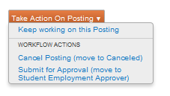
The Student Employment Initiator may “Keep working on this Posting”, “Cancel Posting (move to Canceled) or “Submit for Approval (move to Student Employment Approver)” for review.
The Student Employment Approver in the business center will receive an email notifying them that the student posting is ready for their review.

If the Student Employment Approver has questions, or is requiring changes, they will either contact you directly or select the option to “Return to Student Initiator”. If returned, view the History section for instruction and once complete, submit the posting to the Student Employment Approver for further review.

CONTACT YOUR HR CENTER TEAM IF YOU NEED ASSISTANCE.

