Benny Hire Finance Review Role
The finance review stage of the Benny Hire appointment process for graduate assistants is a critical check to ensure both the salary and the tuition remission will post against the correct index and account code. There is also an optional activity code field that can be entered, if applicable. Additionally, Benny Hire contains an embedded link to CORE, from which the finance reviewer can check balances on the index(es) from which the appointment will draw salary and fringe. This stage of the appointment process is displayed on the Finance Review tab, which looks like this:
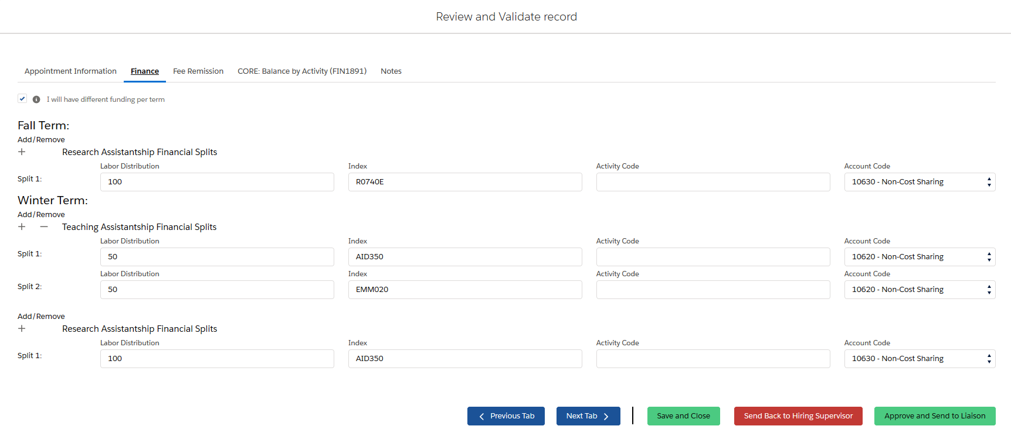

When the appointment is routed to this stage, the finance reviewer should be verifying the following:
- The appointment is being made on the correct index and, if applicable, activity code. While Benny Hire does verify that the index entered is valid (i.e., it is currently active in Banner), the finance reviewer should still check that it is the correct index for the appointment and Criminal History Check if applicable. Examples of errors that Benny Hire will not reject include:
- Indexes on grants that have expired but which are not yet terminated in Banner.
- Activity codes which should be used with a specific index, but which were omitted by the hiring supervisor.
- Incorrect activity codes
- The account code is correct. Benny Hire gives hiring supervisors the option to enter the appropriate salary account codes, depending on whether the appointment is a Graduate Research Assistant or a Graduate Teaching Assistant. Additionally, the pre-populated account code choices include cost share account codes. The finance reviewer should make sure all account codes are correct for the appointment type. If the appointment will be part of a cost sharing commitment, the appropriate account codes should be used to reflect that.
Benny Hire has embedded logic which will result in an error message if the hiring supervisor enters a Graduate Teaching Assistant position on a sponsored project index. In the very rare cases when that is actually the correct entry, the finance role can move forward with the verification as the error message is informational only and will not stop the hiring process.
NOTE: A concurrent fee remission position is also created within Benny Hire, which will default to mirror the labor distribution that was entered on the C60xxx position.
- For easy reference, the finance role includes a link to CORE report FIN1891, so the finance reviewer can check the financial status of the index(es) against which the appointment is being made. This report is accessible from within Benny Hire on the “CORE balance by Activity (FIN1891)” tab, which looks like this:
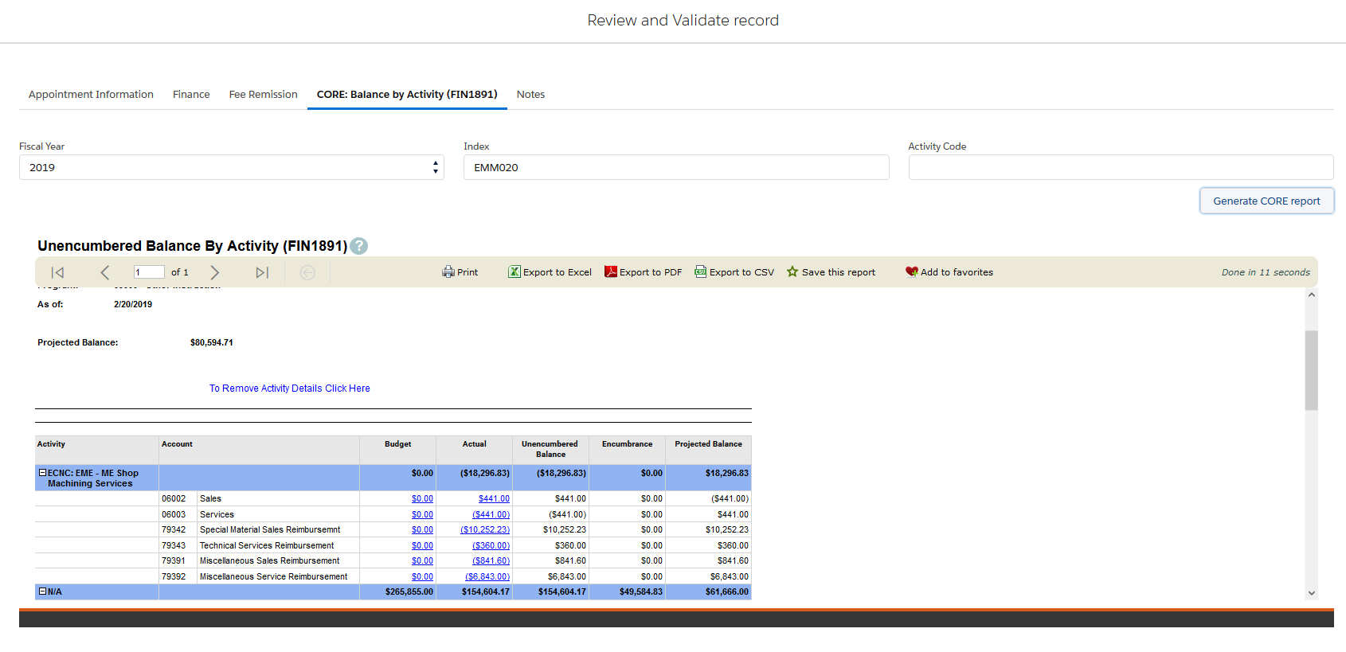

- The finance reviewer has the option to correct/override any incorrect index, activity code, or account code elements or to add a missing activity code, if appropriate. Alternatively, the finance reviewer may choose to send the appointment back for the hiring supervisor to re-enter the appointment with the correct information by choosing the “send back to hiring supervisor” tab at the bottom of the finance tab screen (see screen shot on previous page).
- If there is any additional information which the finance reviewers feels should be noted in the record, that can be entered in the “Notes” tab, which is shown below:
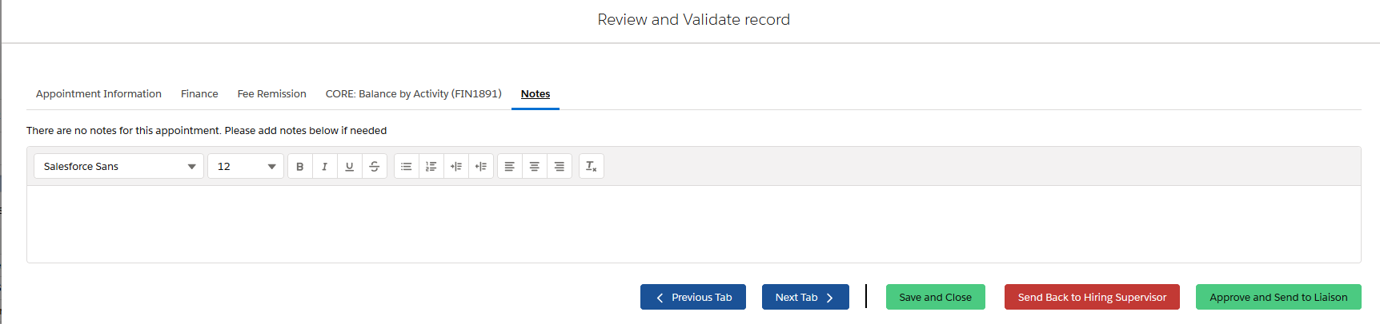

- Once all the information and the financial status has been reviewed and deemed correct/appropriate, the finance reviewer will select “approve and send to liaison” at the bottom of the tab. This action will confirm that the finance review has been completed and forwards the appointment to the next stage in the process.

