How to View a Position Description
  - In the Online Recruiting System (PeopleAdmin)

To login visit https://jobs.oregonstate.edu/hr and select the yellow link as indicated in the screenshot below.

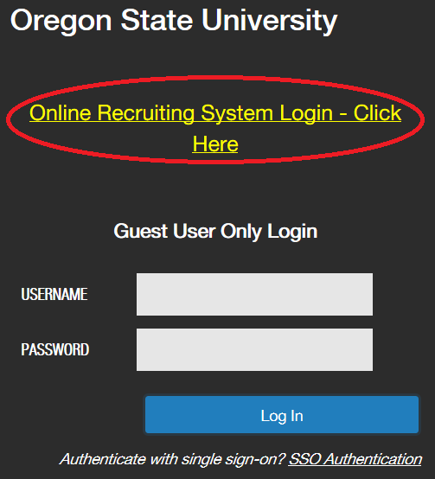

You will then be prompted to enter your ONID credentials and authenticate via DUO

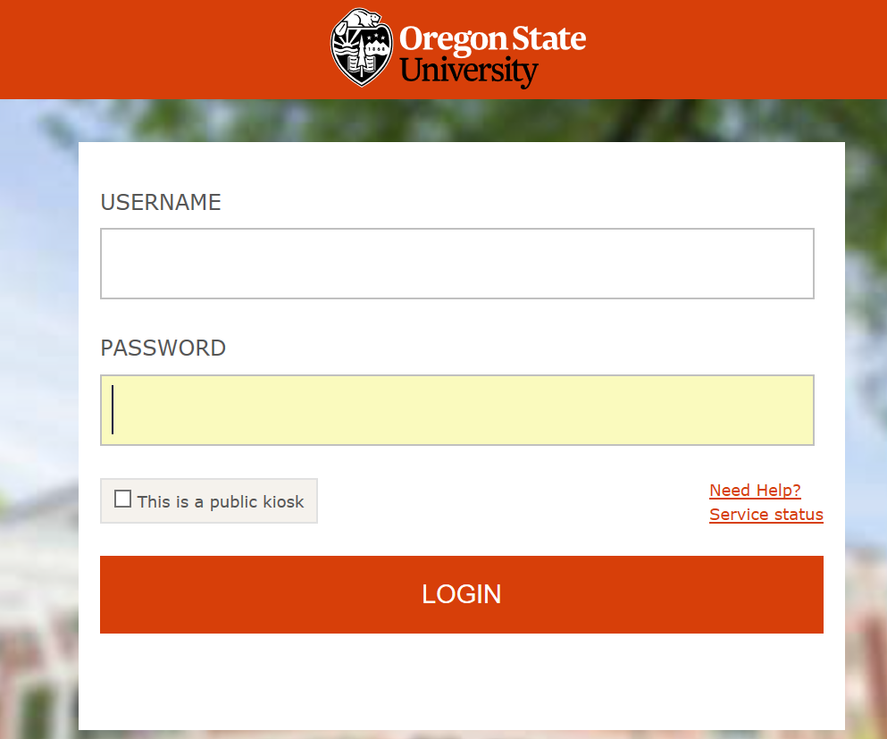

The system will typically open to the “Applicant Tracking” module (blue) on the Home page as indicated in the screenshot below.

Employee Quick View: All non-student employees may access their own position description by selecting the “My Profile” link in the upper right hand corner of the screen and then the “Position Descriptions” tab.

Supervisors may also access the position descriptions of the employees who report to them by following the steps indicated below.

To view a position description, you will need to change from the “Applicant Tracking” module by clicking the three blue dots in the upper left hand corner of your screen and selecting the “Position Management” module. Once here, choose the “Employee” user group from the drop down menu (if not already chosen).

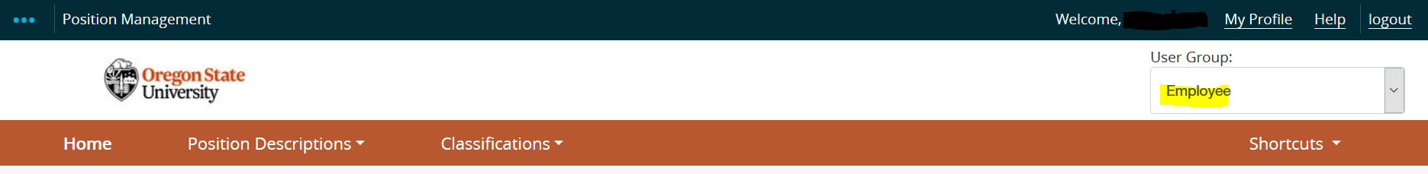

Next, select the “Position Descriptions” drop down menu: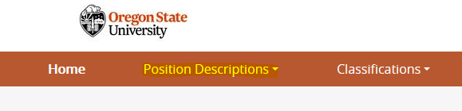
Four options will appear and you will want to select one of the highlighted options below depending on the position type of the employee(s) you wish to view.

- Classified/Temporary Staff
- Classified/Temporary Staff Position Requests
- Unclassified Faculty*
- Unclassified Faculty Position Requests

Once you select the appropriate option, you will see a list of position descriptions for which you have access.

*The Unclassified Faculty section includes academic teaching/research faculty, administrative/professional faculty and academic wage appointment types.

To view a position from your list, select “View” from the “Actions” drop down menu next to the position description listed or one of the hyperlinks provided.

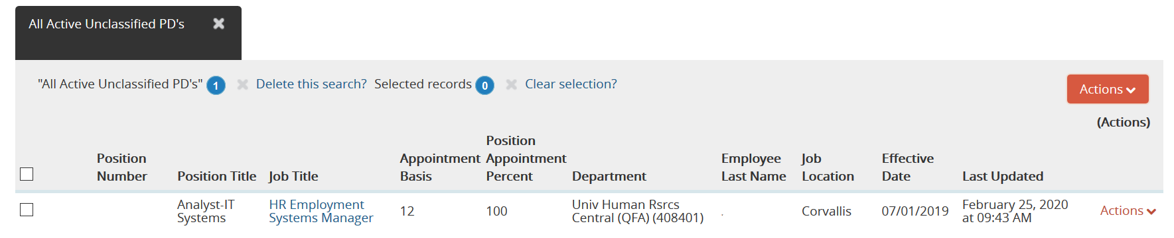

Once open for viewing, you can also print the position description using the print link(s) provided.

If you wish to create/develop or modify a position description, complete the Position Description template, managed by Classification and Compensation, and submit to position.descriptions@oregonstate.edu.

Please contact employment@oregonstate.edu if you need assistance or if you are missing position descriptions that you should have access to in your supervisory or employee role.

